PS-11: RICE GRAIN VARIETY CLASSIFICATION
Convolutional Neural Network Baseline for Five Rice Varieties
Name | S K KARTHIKESH
Register No. | RA2311026050066
Section | IV CSE-AIML-A
Course | Deep Learning — CBL
Date | 23 October 2026
GitHub | https://github.com/Karthi9548/PS11-Rice-Grain-Classification

1. Problem and Objective
Rice grain varieties can have similar visual characteristics, making automated identification useful for quality control in rice mills and agricultural processing. This project develops a Convolutional Neural Network (CNN) to classify rice grain images into Arborio, Basmati, Ipsala, Jasmine and Karacadag. Performance is evaluated using held-out test accuracy, macro F1-score and the confusion matrix.

2. Dataset and Pre-processing
The Rice Image Dataset from Kaggle contains 75,000 images, with 15,000 images per variety (Fig. 1). A balanced subset of up to 200 images per class was randomly sampled, giving 1,000 images. Images were converted to RGB, resized to 96 × 96 pixels and normalised to the [0, 1] range. A fixed random seed of 42 was used for stratified training, validation and test splits of 70%, 15% and 15%. All 1,000 sampled images loaded successfully, giving 700 training, 150 validation and 150 test images (Fig. 2).
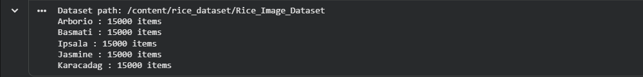
Fig. 1. Dataset verification: 15,000 images per variety in the extracted Kaggle dataset.
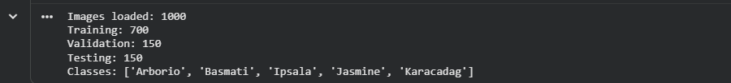
Fig. 2. Stratified split of the 1,000 sampled images (700 / 150 / 150) and class labels.

3. Methodology
A CNN was trained from scratch using TensorFlow/Keras 2.21.0 on a CPU runtime (no GPU). The architecture comprises three convolutional blocks with 32, 64 and 128 filters (3 × 3 kernels), max pooling after the first two blocks, global average pooling, a 64-unit dense layer, dropout (0.3) and a five-unit softmax output. The model uses the Adam optimiser and sparse categorical cross-entropy loss, and was trained for five epochs with a batch size of 32. Validation data were used to monitor training; the test set was used only for final evaluation.
Hyperparameter | Value
Input size | 96 × 96 × 3
Training subset | Up to 200 images/class (1,000 total)
Split (train/val/test) | 700 / 150 / 150 (stratified)
Optimiser | Adam
Loss | Sparse categorical cross-entropy
Regularisation | Dropout 0.3
Batch size | 32
Epochs | 5
Random seed | 42

4. Results
The final model achieved 64.00% test accuracy and a 0.6160 macro F1-score on the 150-image test set (96 of 150 images correctly classified).
Metric | Result
Test accuracy | 64.00%
Macro F1-score | 0.6160
Test images | 150
Training images | 700

Training progressed steadily over the five epochs: validation accuracy rose from 20.00% to 65.33% and validation loss fell from 1.5524 to 1.0536 (Fig. 3). Validation accuracy exceeds training accuracy in the last epoch because the training metric is averaged over the epoch while dropout is active, and because the weights were still improving rapidly. Both curves were still moving when training stopped, so the model is under-trained rather than over-fitted.
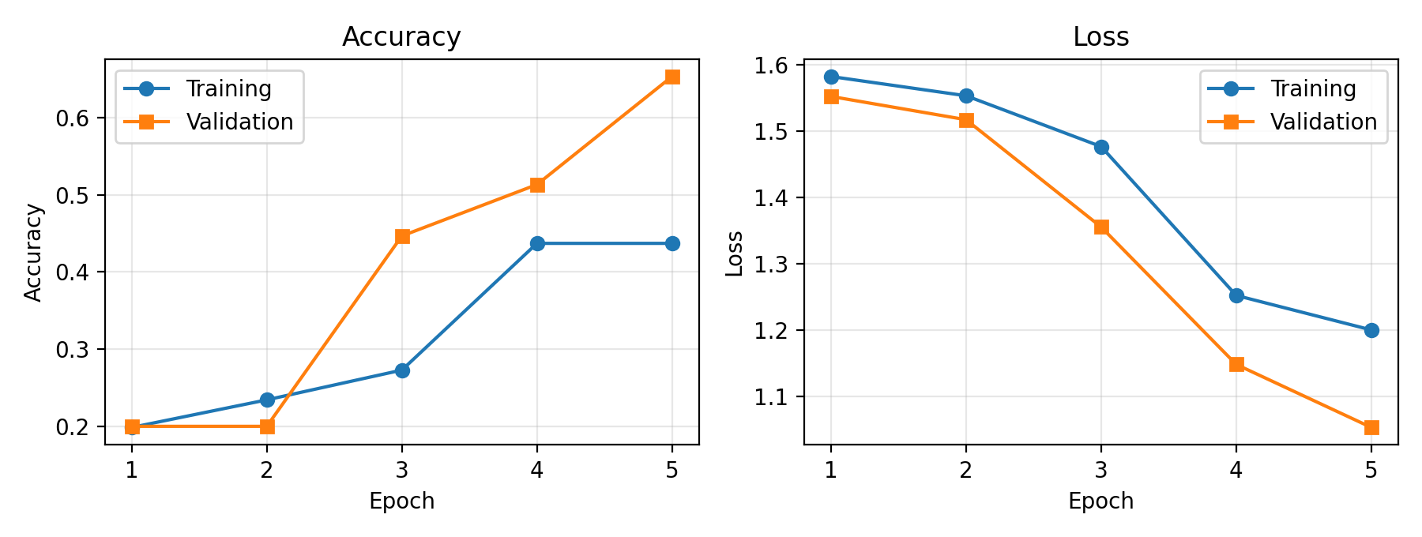
Fig. 3. Training and validation accuracy/loss across the five epochs (values from the training log).
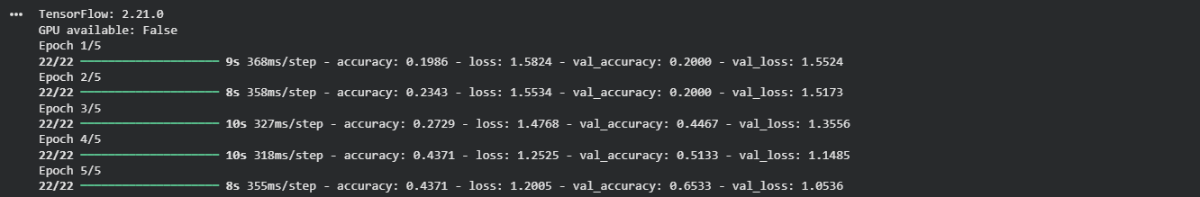
Fig. 4. Keras training log for the five epochs.
Class | Precision | Recall | F1-score | Support
Arborio | 0.60 | 0.30 | 0.40 | 30
Basmati | 0.51 | 0.60 | 0.55 | 30
Ipsala | 0.86 | 1.00 | 0.92 | 30
Jasmine | 1.00 | 0.37 | 0.54 | 30
Karacadag | 0.52 | 0.93 | 0.67 | 30
Macro average | 0.70 | 0.64 | 0.62 | 150
Table. Per-class test performance (from the executed classification report).
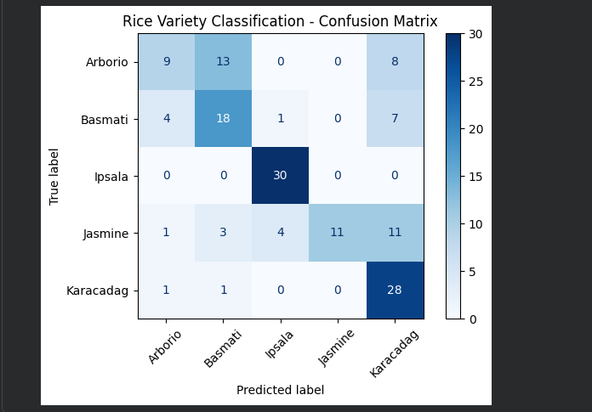
Fig. 5. Confusion matrix on the held-out test set (rows = true label, columns = predicted label).

5. Analysis and Discussion
Ipsala was classified best (F1 = 0.92, recall = 1.00): all 30 test images were correct, which suggests its grain shape is the most distinctive. Karacadag reached F1 = 0.67 with high recall (0.93) but low precision (0.52): the model uses Karacadag as a default prediction, and 26 of its 54 Karacadag predictions were wrong. Arborio (F1 = 0.40) and Jasmine (F1 = 0.54) were weakest. Jasmine had perfect precision (1.00) but recall of only 0.37, so the model rarely predicts it and misses most Jasmine grains.
The confusion matrix shows four main error patterns:
- Arborio → Basmati (13 of 30) and Arborio → Karacadag (8 of 30): only 9 Arborio grains were correct.
- Jasmine → Karacadag (11 of 30) and Jasmine → Ipsala (4 of 30): Jasmine was confused mainly with Karacadag.
- Basmati → Karacadag (7 of 30): a smaller but consistent leak into the Karacadag class.
- Basmati ↔ Arborio: 4 Basmati grains were predicted as Arborio and 13 Arborio as Basmati.
A likely cause is that, at 96 × 96 resolution on a short 5-epoch run, the network has not yet learned the fine shape and texture differences between these elongated, similarly coloured grains. This explanation was not tested experimentally here.
Misclassified examples. Four misclassified test images with their true and predicted labels, drawn from the patterns above, are shown in Fig. 6.
[INSERT FIG. 6 HERE — 2 × 2 grid of four misclassified test images; generate it with the code cell supplied separately, then delete this line]
Fig. 6. Four misclassified test images (true label → predicted label), with a one-line explanation per image.
The model was trained on only 1,000 of the 75,000 available images, so these results should not be interpreted as performance on the entire dataset.
Demonstration. The trained model was wrapped in a Gradio web interface (Fig. 7). The interface also exposes the test accuracy, classification report and confusion matrix. Prediction probabilities for single grains are close to uniform (e.g. Basmati at 27.09% on the example shown, against 20% for random guessing), which agrees with the modest accuracy and shows the model is not yet confident.
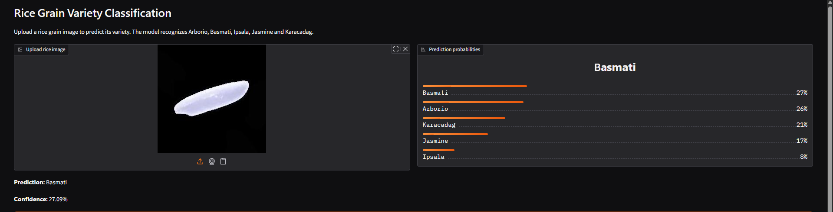
Fig. 7. Gradio demo: uploaded grain image, predicted variety, class probabilities and model-evaluation summary.

6. Real-world Relevance, Limitations and Ethics
The system could support preliminary rice-variety identification in agricultural processing and quality control. However, its current accuracy and limited training sample do not justify unsupervised industrial deployment: a 36% error rate, with some classes recovered less than 40% of the time, would be unacceptable for grading or labelling decisions. Key limitations are the small training subset (200 images per class), the short training schedule, the absence of data augmentation or hyperparameter tuning, a single random split without repeated runs, and a small test set (30 images per class), so per-class figures carry substantial uncertainty. The dataset consists of controlled, uniform-background images, so performance on mill-floor photographs with different lighting, backgrounds and grain mixtures is unknown. Further validation using larger and more diverse image collections, improved augmentation, hyperparameter tuning and independent testing is required. Dataset provenance, licensing, reproducibility and potential visual-domain bias should also be considered, and any misclassification could affect producers or consumers if used for labelling or pricing.

7. Conclusion and Future Work
A CNN-based rice classification baseline was developed for five varieties, achieving 64.00% test accuracy and a 0.6160 macro F1-score using 1,000 images and five epochs of training. Ipsala was identified reliably, whereas Arborio and Jasmine were frequently confused with Basmati and Karacadag. Future work will focus on training on more images for more epochs, adding augmentation, analysing misclassifications further, and comparing the baseline with transfer-learning models such as MobileNetV2 or EfficientNet.

References and Declarations
Dataset: Rice Image Dataset, Kaggle (M. Koklu). https://www.kaggle.com/datasets/muratkokludataset/rice-image-dataset
Repository: https://github.com/Karthi9548/PS11-Rice-Grain-Classification
AI-use declaration: AI assistance was used to support code development and report preparation. All reported results are based on the executed notebook and should be verified against its outputs.

